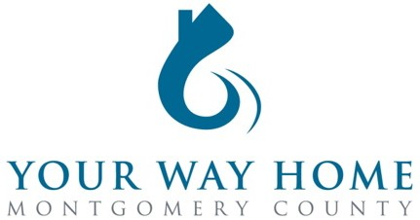

Your Way Home Montgomery County
Continuum of Care (COC)/Emergency Food & Shelter (EFSP) Governing Board Meeting

October 28, 2022 | 11:00 AM – 12:00 PM
Via Zoom

Agenda
I. Welcome
II. Welcome New Team Members – Office of Housing & Community Development
o Sabrina Lyons – Homeless Prevention Programs Manager
▪ ERUC/ERAP, EPIC, HOME TBRA, School-Based Initiatives
o Trevor Reinhardt – Your Way Home Data Manager
III. Review & Vote on EFSP: Phase 39 and New Phase 40
o Spending Deadline December 31, 2023
IV. Your Way Home Policy and Procedure Manual 2022 Updates
o Highlight> Current Stats/Data and 2023 Provider Trainings
o Any changes or recommendations, send by email to all CoC by November 4th or as approved by CoC Board
V. Housing Resource Centers Performance and Outcomes
VI. Feedback & Input, Announcements, Closing Statements (Open to Group)
VII. Adjourn

