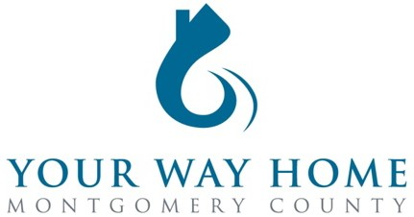

Your Way Home Montgomery County
Continuum of Care (COC)/Emergency Food & Shelter (EFSP) Governing Board Meeting

February 25, 2022 | 11:00 AM – 12:00 PM
Via Zoom

Agenda
- Welcome
- New This Year: Bimonthly Meetings
- Review & Vote on EFSP: Phase 39 ($326,848) & ARPA-R ($1,010,212)
  - 2022 Funding Priority
  - EFSP Application
  - Spending period end date (Final date April 30, 2023)
- Review & Vote: Change charter to increase board seats from 23 to 25*
- Review & Vote: Governing Board Applicants
  - Bio Reviews (11)
  - Vote-in 1 replacement member today (Arlene’s Seat)
    - *Choose 4 of 10 remaining Bios for COC Board Membership
    - Public Vote > Slate or by Individual Candidate
  - Candidate for Chair: Stacy Woodland, CEO YWCA Tri-County Area
  - Candidate for Vice-Chair: Dennis Miller, Administrator Montgomery County Office of Veterans Affairs
- Announcements
- Adjourn

Meeting Attachments:
PA-504 CoC Governing Board Charter June 2021
EFSP: Application
Board Applicant Bios

